**A multi-national, multi-institutional study of assessment of programming skills of first-year CS students**

Programming is one of many skills that computer science students are expected to master. In addition, most science, mathematics, engineering, and technology (SMET) programs expect that their students will acquire programming skills as a part of their education. The question is whether these requirements are being met. We think not, but wanted to gather evidence that would confirm or refute our observations.

Do students in introductory computing courses know how to program at the expected skill level? This working group collected data from several universities and found that the students’ level of skill was not commensurate with their instructors’ expectations.

For first-year computing students, a fairly universal expectation is that they should learn the process of solving problems in the domain of computer science, in order to produce compilable, executable programs that are correct and in the appropriate form.

To help determine the programming ability of first-year computing students, the working group developed a set of three related programming exercises that students at several universities would be asked to solve. The exercises, which varied in difficulty, were designed so that, theoretically, students in any type of Computer Science programme should be able to solve them.

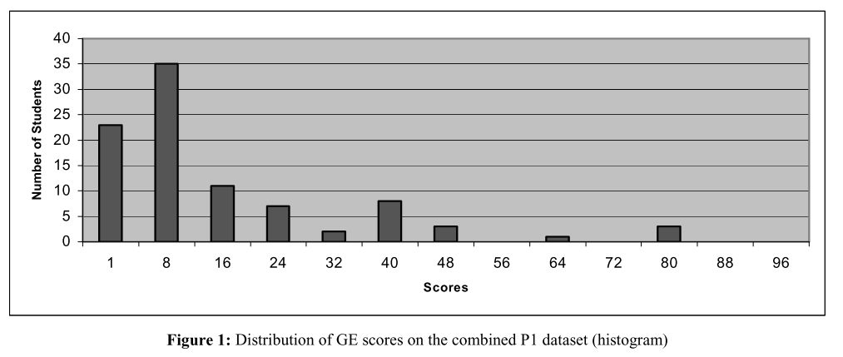

Analysis of General Evaluation Score The average General Evaluation (GE) score (combining the execution, verification, validation, and style components) for all students, all exercises, at all schools (n = 217) was 22.9 out of 110 (standard deviation 25.2).

Though the scores are uniformly low, as a percentage of possible scores, students did best on the execution component (implying that, overall, they wrote programs that compiled and ran) and the style component (implying that the source code looked good). The lowest component scores were on the verification and validation components (Table